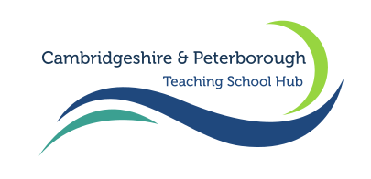
Cambridgeshire and Peterborough Teaching School Hub: Our associated curriculum hubs
All Hubs are funded by the DfE.
Hub | Notes | Website link
Music Hubs  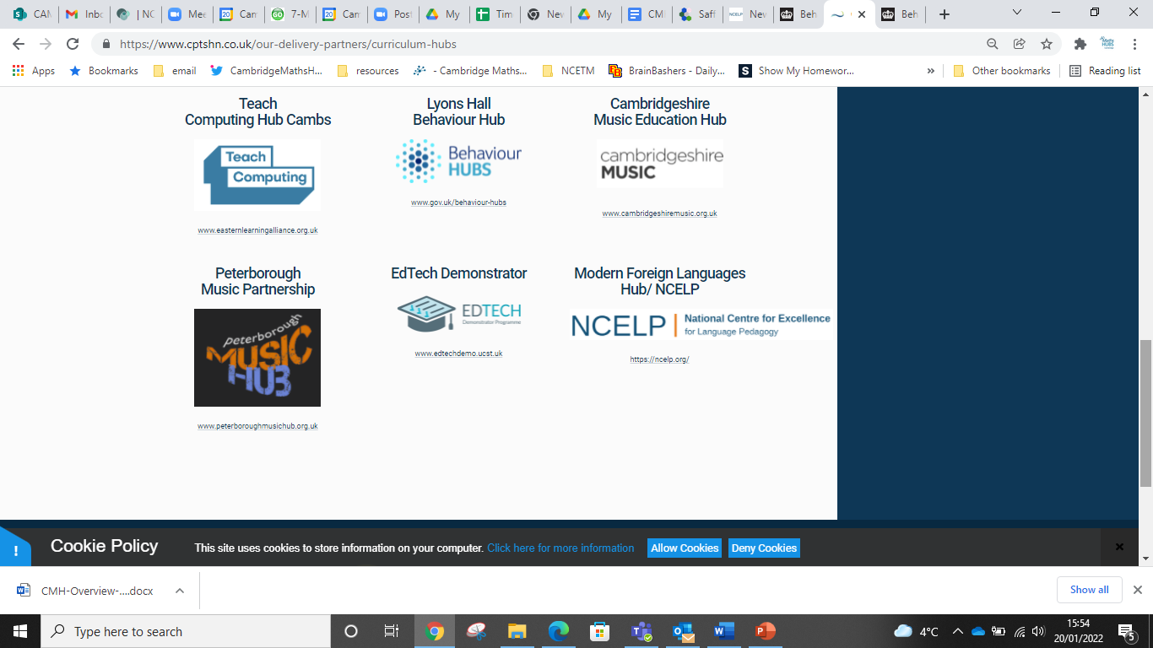   | Music Hubs ensure that every child aged 5-18 has the opportunity to learn a musical instrument (other than voice) through whole class ensemble teaching programmes for ideally a year (but for a minimum of a term) of weekly tuition on the same instrument.  They offer CPD to school staff, particularly in supporting schools to deliver music in the curriculum.  And lots more…  Free consultancy is offered. | Peterborough: https://peterboroughmusichub.org.uk/  Cambridgeshire: https://www.cambridgeshiremusic.org.uk/
Maths Hub  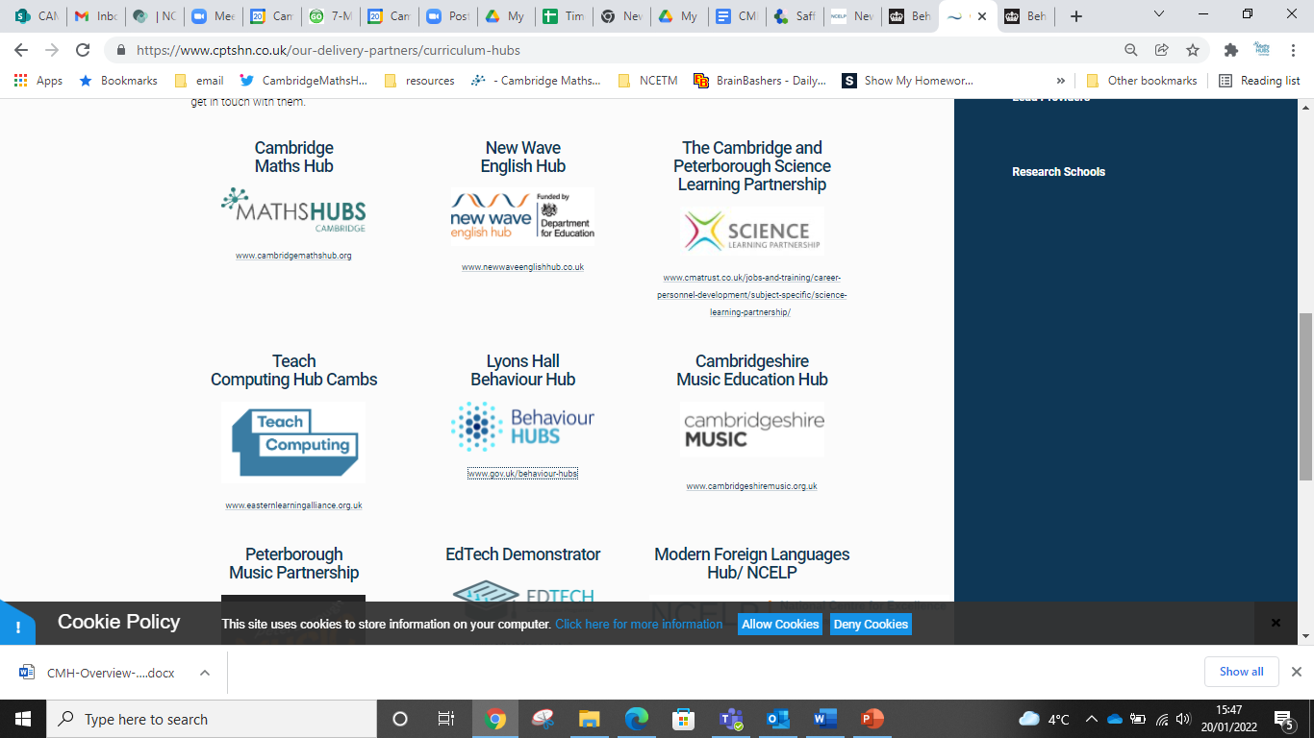 | Teachers work collaboratively in small groups to improve pedagogy. Teaching for mastery is the main focus, looking at developing confidence in mathematical thinking, reasoning and fluency. 85% of schools in Cambridgeshire and Peterborough are participating. | www.cambridgemathshub.org
MFL Hub | The call for applications is now open for the NCELP Continuing Professional Development (CPD) Courses. Our free CPD courses will take an in-depth look at Modern Foreign Language (MFL) curriculum design and pedagogy and will run across three terms in the 2022 calendar year. Five, free remote 2.5-hour secondary sessions focus on the three knowledge strands of Phonics, Vocabulary, Grammar. There’s a session on curriculum design and assessment, and a final session on bringing it all together in meaningful practice. | NCELP – National Centre for Excellence for Language Pedagogy
English Hub  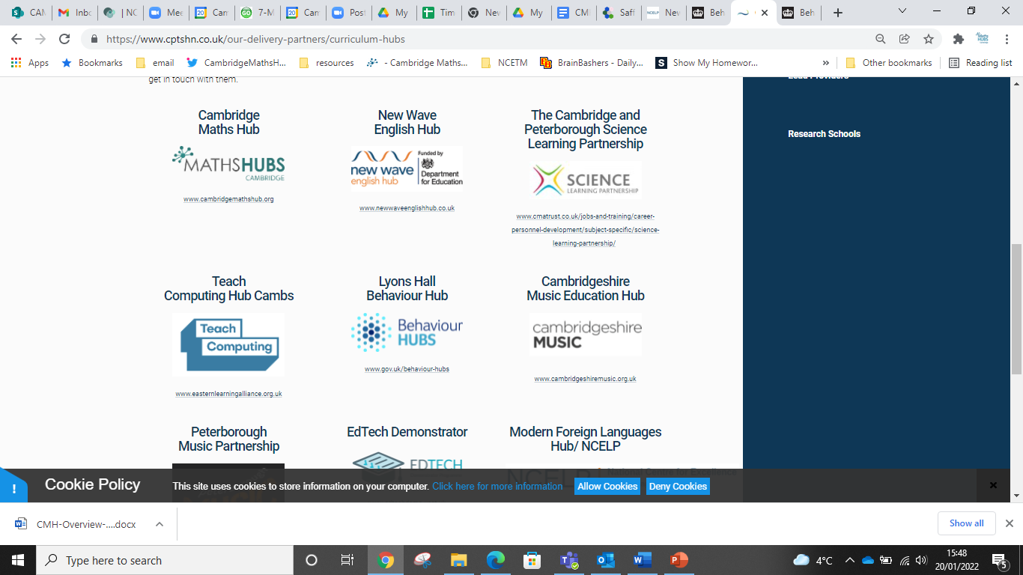 | Our local English Hub is in London. They offer support to primary schools in the teaching of phonics. Find out if you are eligible here. | New Wave English Hub | Hackney, London
Behaviour Hub | Our local behaviour Hub is at Lyons Hall. Please contact them via their website. | Home Page - Behaviour Hubs
Science Learning Partnership | The Cambridge and Peterborough Science Learning partnership can offer CPD for Primary, Secondary and FE teachers to support with the teaching of science  We can offer needs analyses, bespoke training and individualised support and can run training for individual departments or MATs at a time that suits – for example on whole school training days or in after-school department meeting time. | The current programme can be viewed here: https://sites.google.com/view/cambridgeandpeterborough-slp/home  We may be able to provide some bursary funding for training depending on circumstances, please email training@swaveseyvc.co.uk if you would like to discuss what we can offer.
National Centre for Computing Education | There is plenty on offer with CPD, curriculum support and free consultancy. There is also time-limited funding. They are happy to set up bespoke courses for Trusts or groups of schools. | Contact Mandy Honeyman MHoneyman@ccc.tela.org.uk  Website: Teach Computing  For more contact details and up to date information please visit NCCE
East of England Early Years Stronger Practice Hub | The East of England Early Years Stronger Practice Hub is one of 13 DfE designated Stronger Practice Hubs across England. The East of England Hub will cover Suffolk, Norfolk, Cambridgeshire and Peterborough offering bespoke support, EEF evidence informed training opportunities as well as conferences and opportunities to network with others working in Early Years. The hub is fully funded, meaning the offer will always be free to those who take part. The team running the hub are all working within the schools/settings currently and want to offer support across the whole Early Years sector. | Website: Highfield Nursery School - Stronger Practice Hub  Watch a short video about the hub: East of England Early Years Stronger Practice Hub - Meet the team… - YouTube

Contact us at Cambridgeshire and Peterborough:

Email: SCrowley@CPTSHN.co.uk
Number: +44 1223 491670

